Chapter 1, Problem 5.
Determine the total charge transferred over the time interval of 0 ≤ t ≤ 10s when 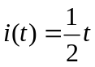 A.

